

COMPUTER NETWORKS

ASSIGNMENT # 1

https Analysis

Submitted by: Izza Iqbal
Registration no: B23F0317AI119
Submitted to: Dr Adnan Iqbal
Department: BSAI Red
Date: 22nd Sep 2025

HTTPs Website Analysis:
I have attach the file to capture https, in which I did the following steps
Steps:
- Setting Up for HTTPS Capture
- Set TLS Filter: Use filter tls or ssl
- Start New Capture
- Accessing HTTPS Website
- Analyzing HTTPS/TLS Traffic

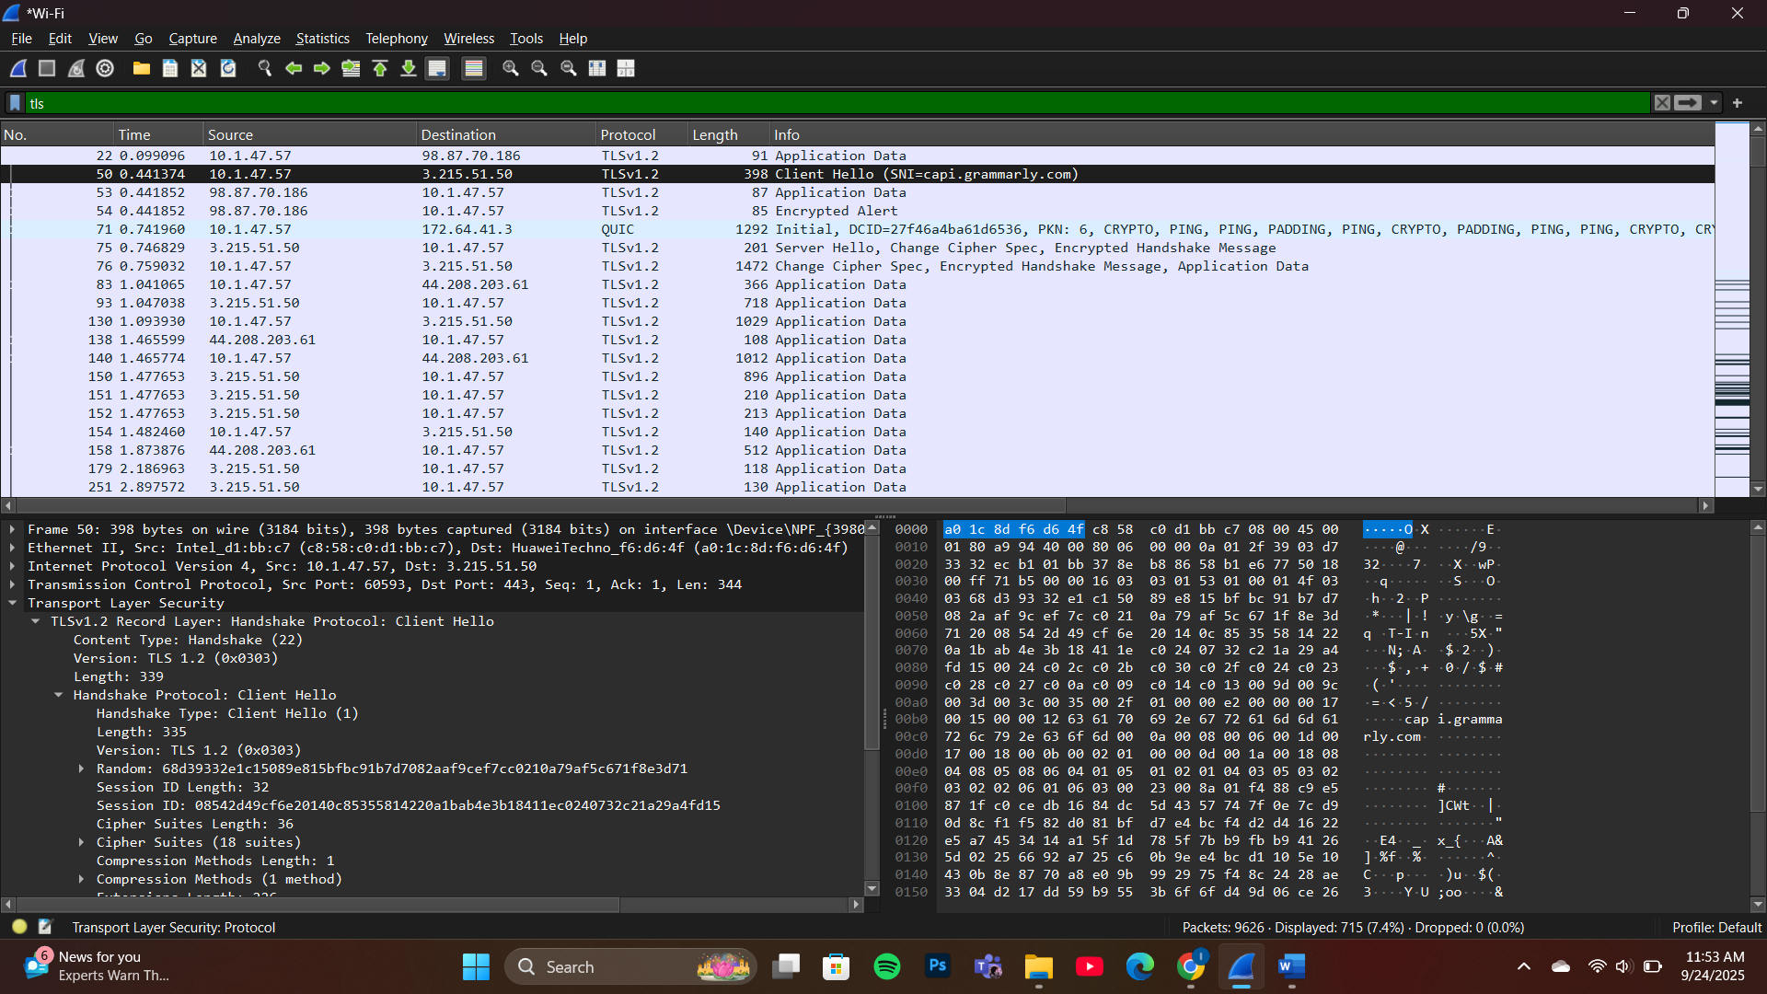

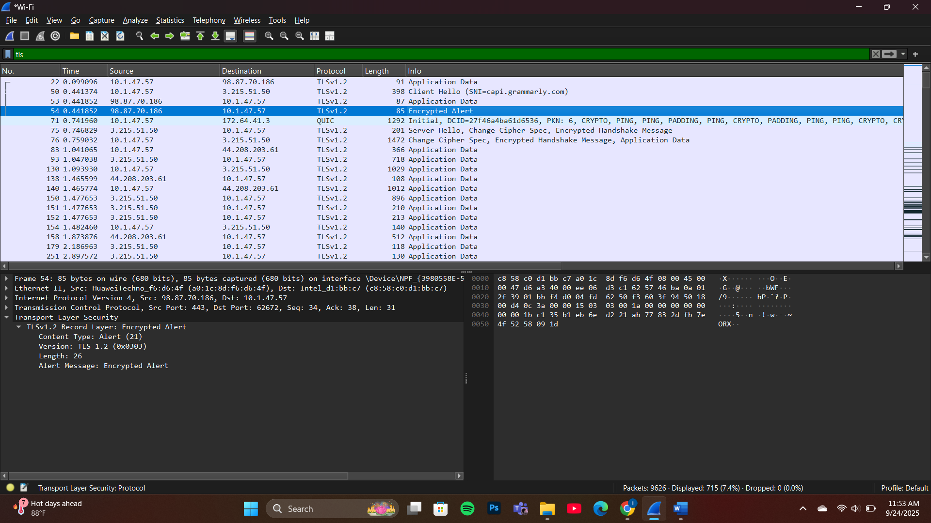

Questions:
Qno 1: HTTPS Website Name
Method: Look at TLS handshake packets
Location: Client Hello packet → Server Name Indication (SNI) extension
Answer: Record the server name
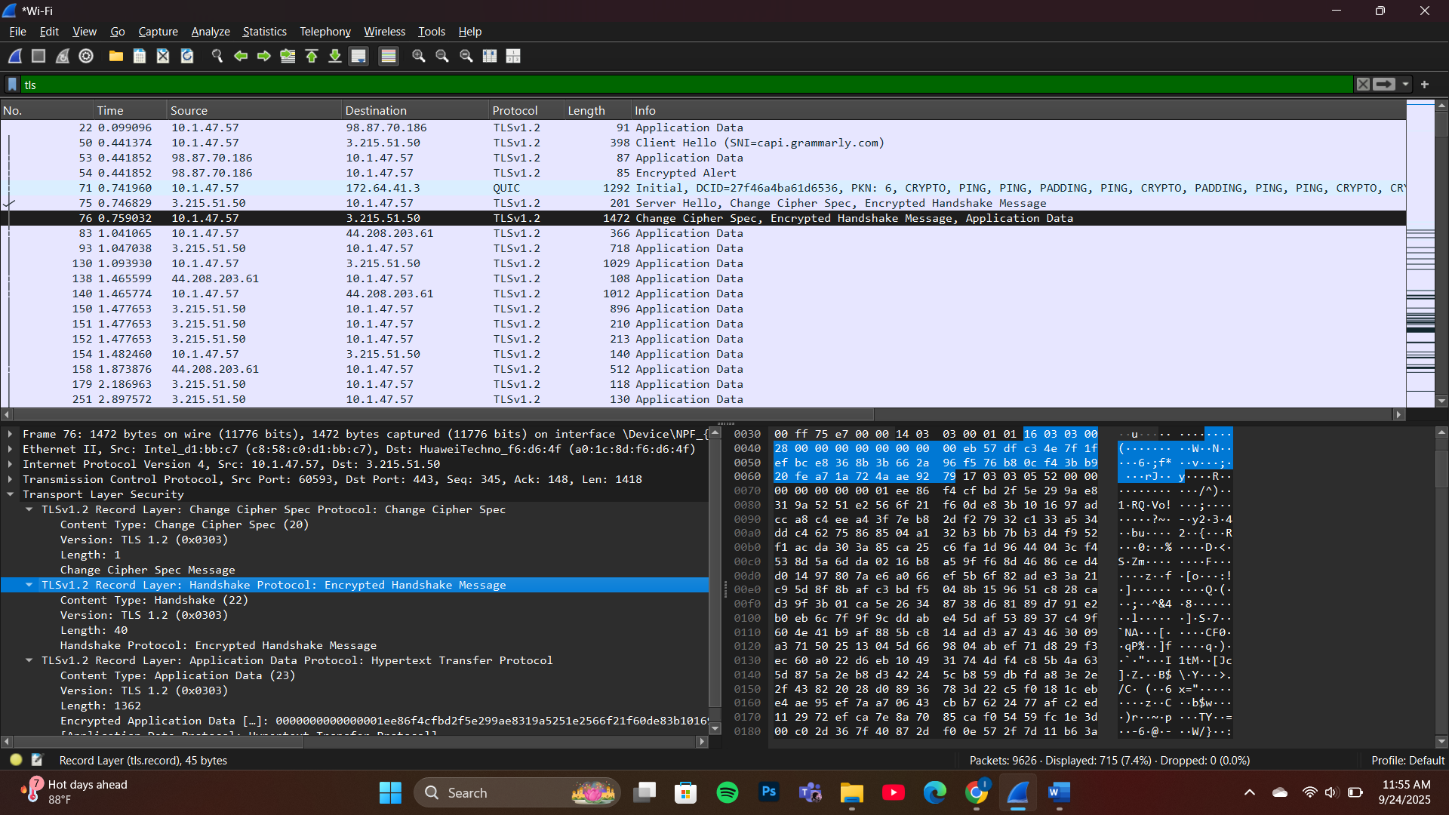

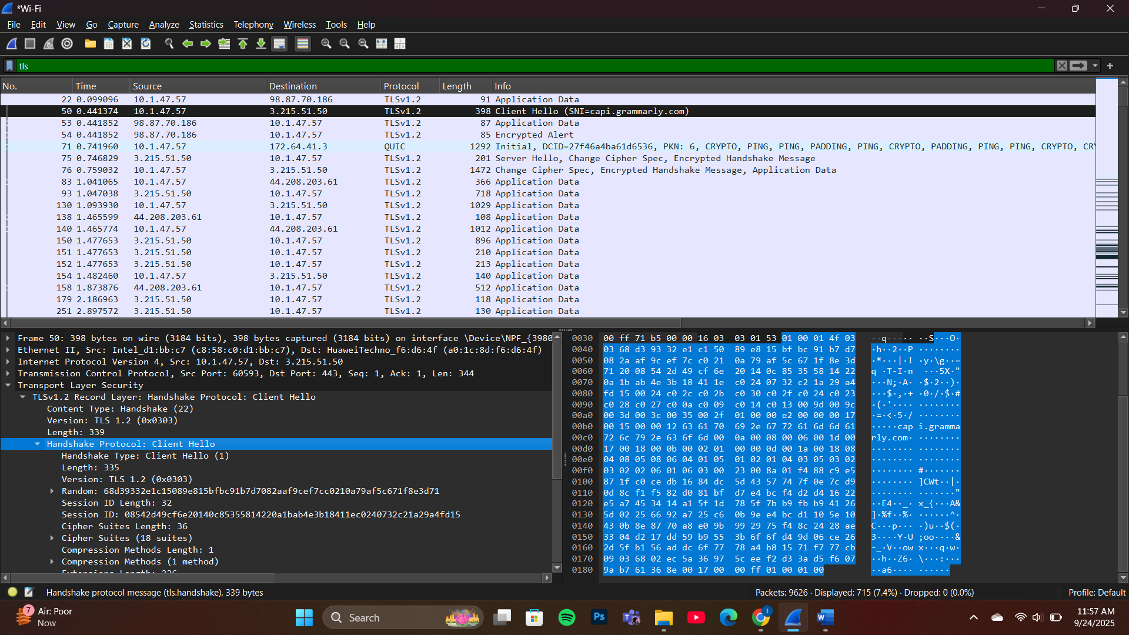

Method: Analyzed TLS handshake packets, specifically Client Hello message
Location: Client Hello packet → Server Name Indication (SNI) extension
Finding: cap1.grammarly.com

Evidence:
  - Packet #50 shows "Client Hello (SNI=cap1.grammarly.com)"
  - TLS version: 1.2
  - Complete TLS handshake captured with SNI extension visible
  - Server Name Indication clearly identifies the target server

Qno 2: ClientHello Message Analysis

Find ClientHello packet: Look for TLS handshake packet with "Client Hello"
Examine details: Expand Transport Layer Security → TLS Record → Handshake Protocol

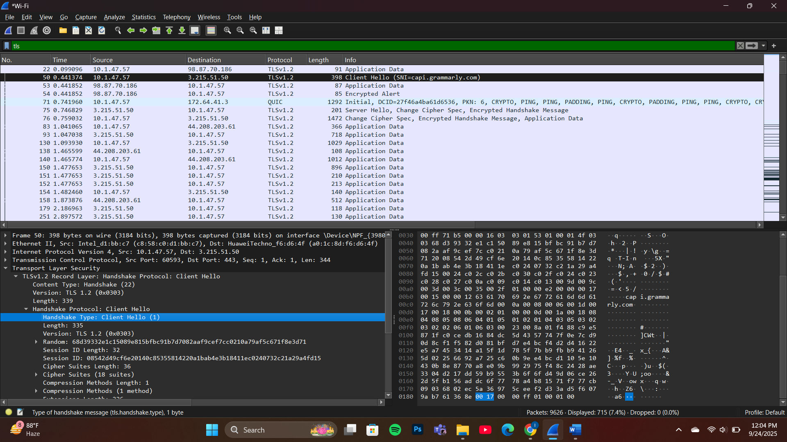

Qno 3: ServerHello Message Analysis
- Locate ServerHello: Find corresponding "Server Hello" packet

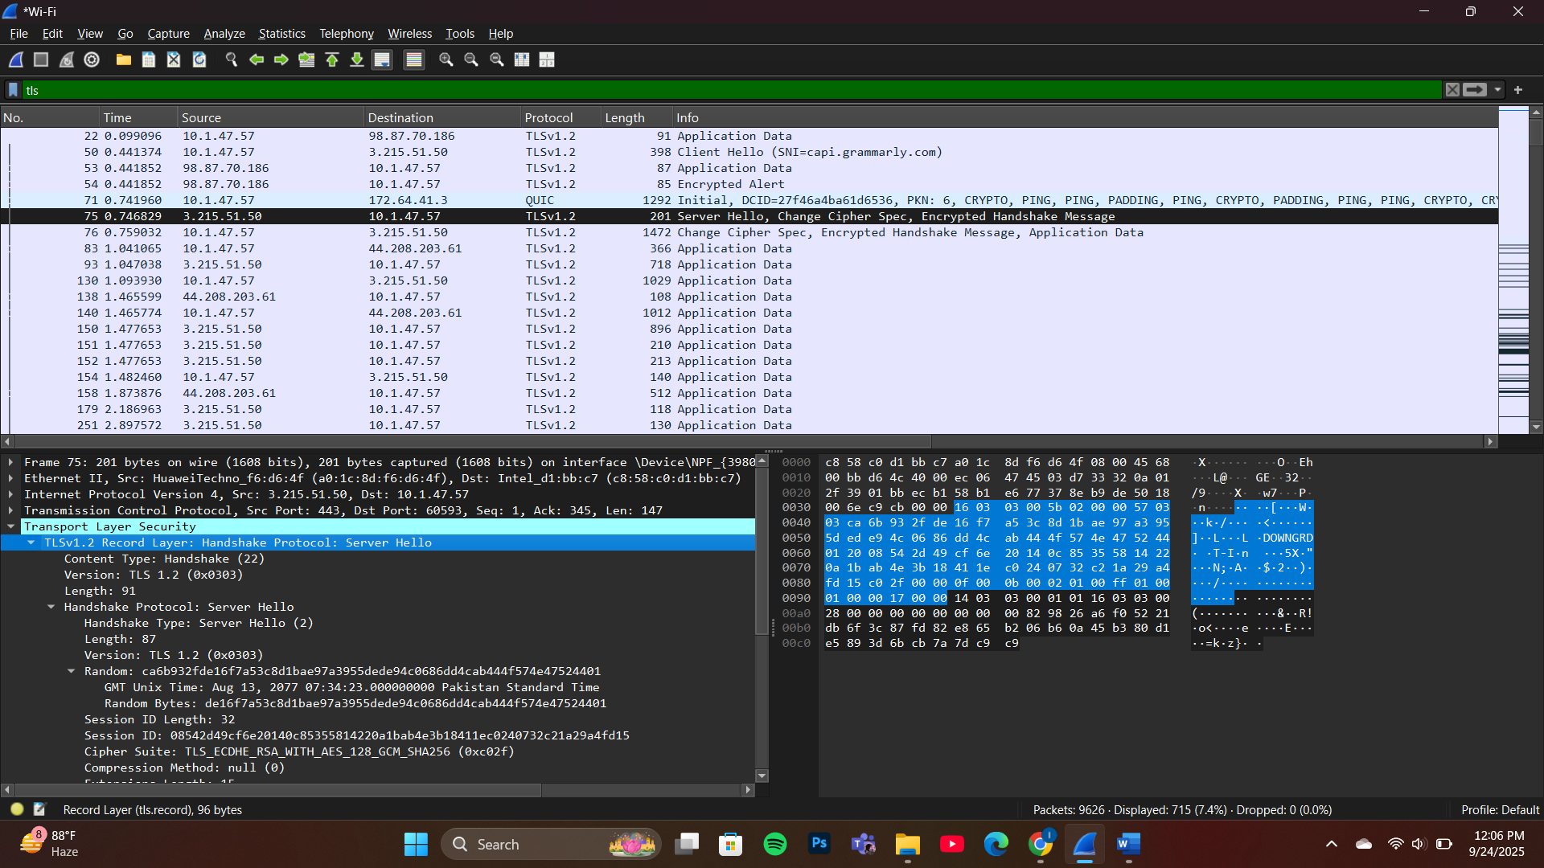

- Extract information: Note cipher suite chosen by server

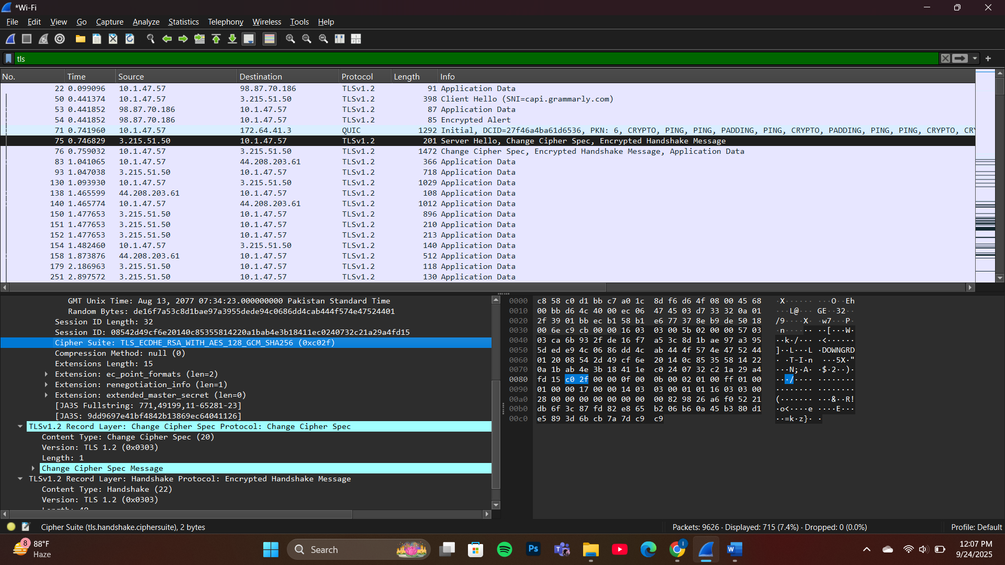

Qno 4: Server Certificate Message
- Find Certificate packet: Look for "Certificate" in TLS handshake

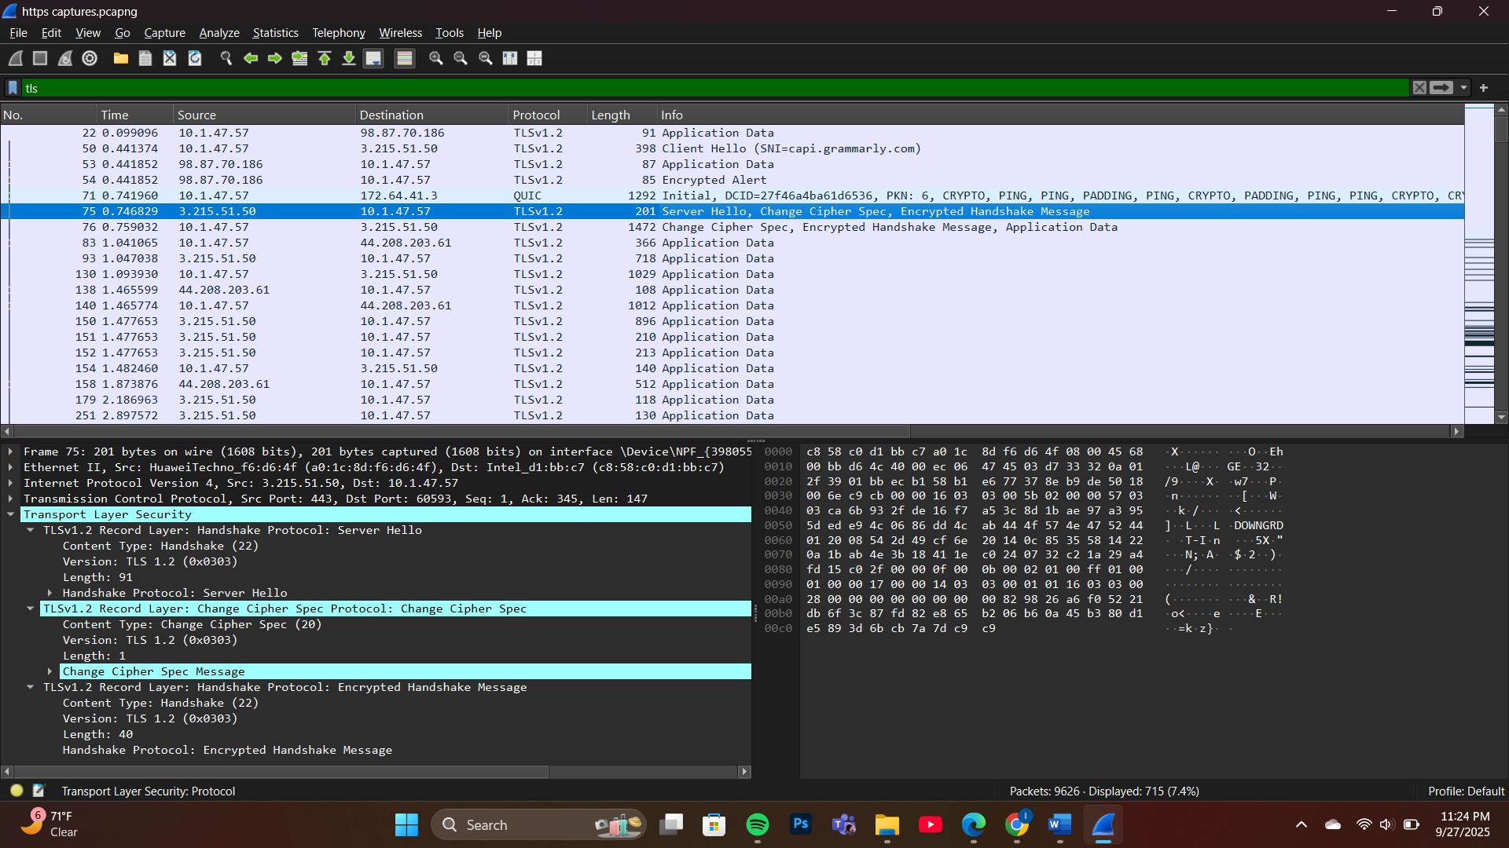

- Cipher suite identification: Note the selected cipher algorithm

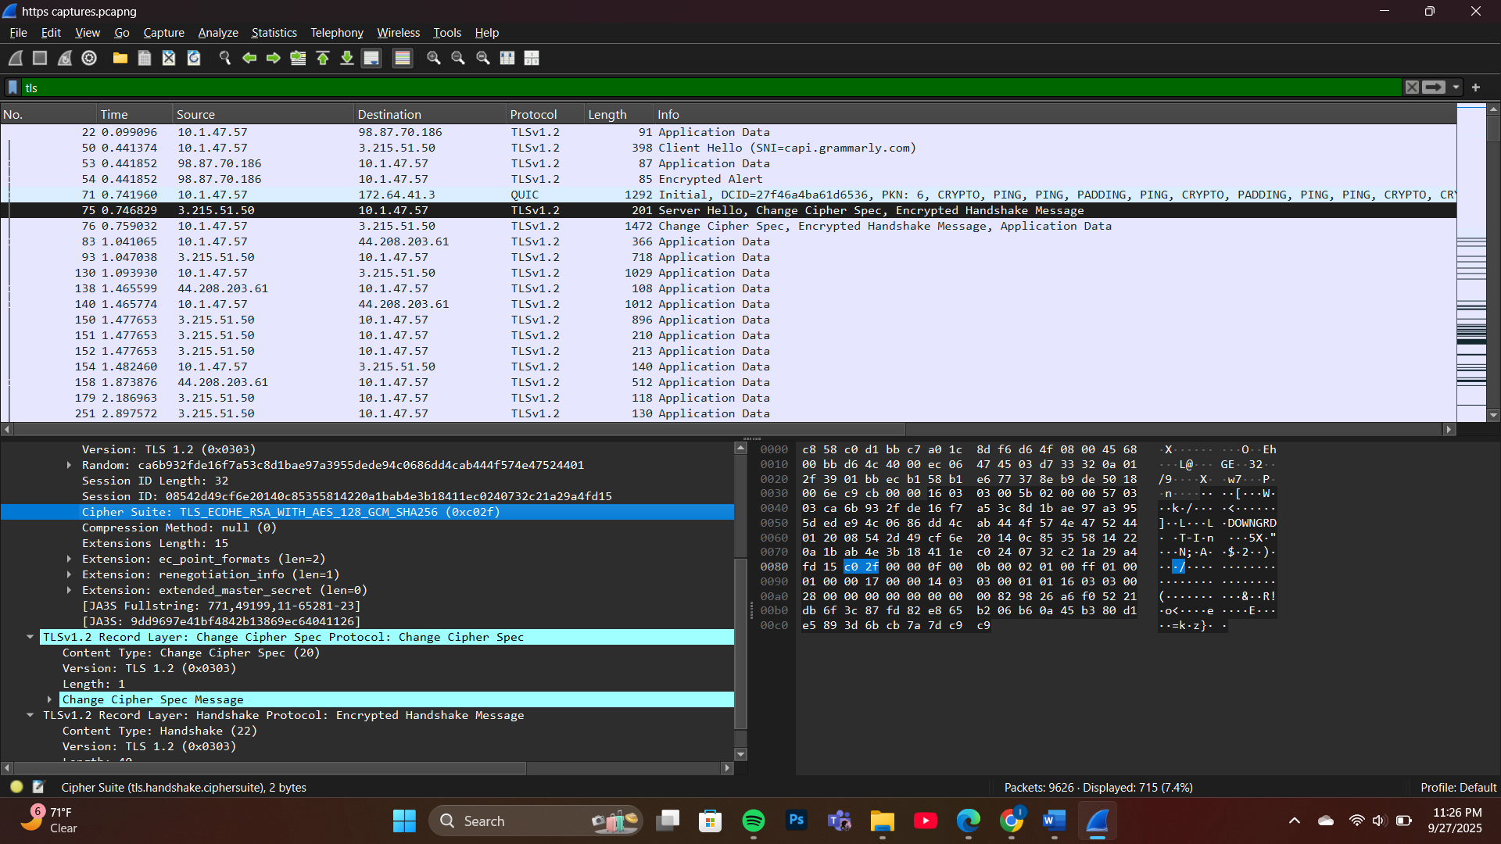

Qno 5: Certificate Message Analysis
- Extract server certificate: Expand certificate details
- Information to record: Subject name, validity dates, subject alternative names

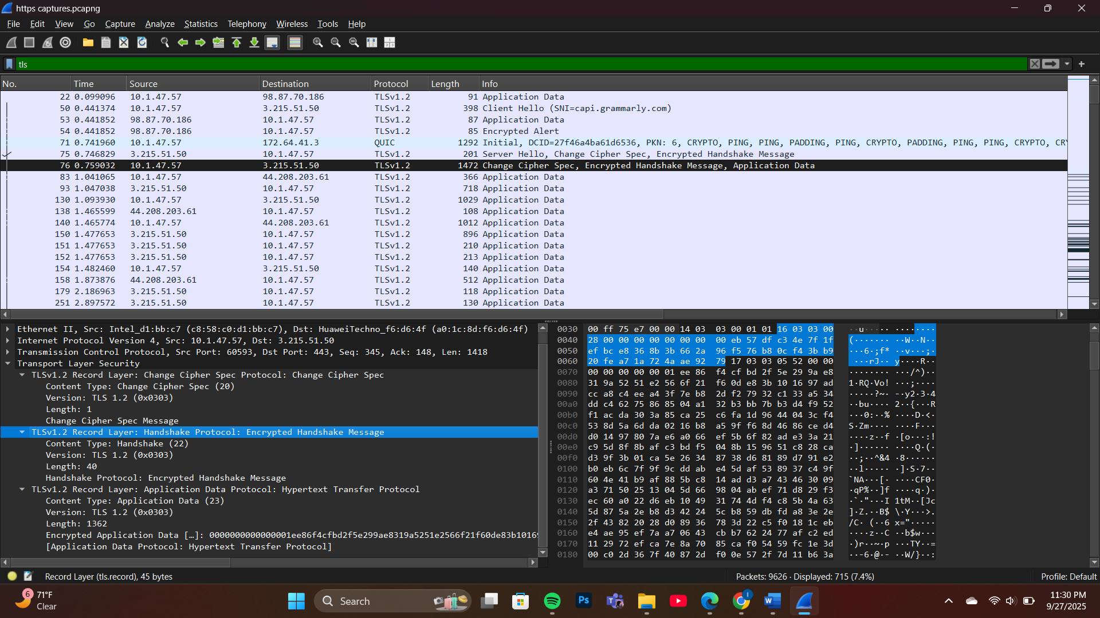

Qno 6: TLS Handshake Completion
- Identify encrypted application data: Look for "Application Data" packets
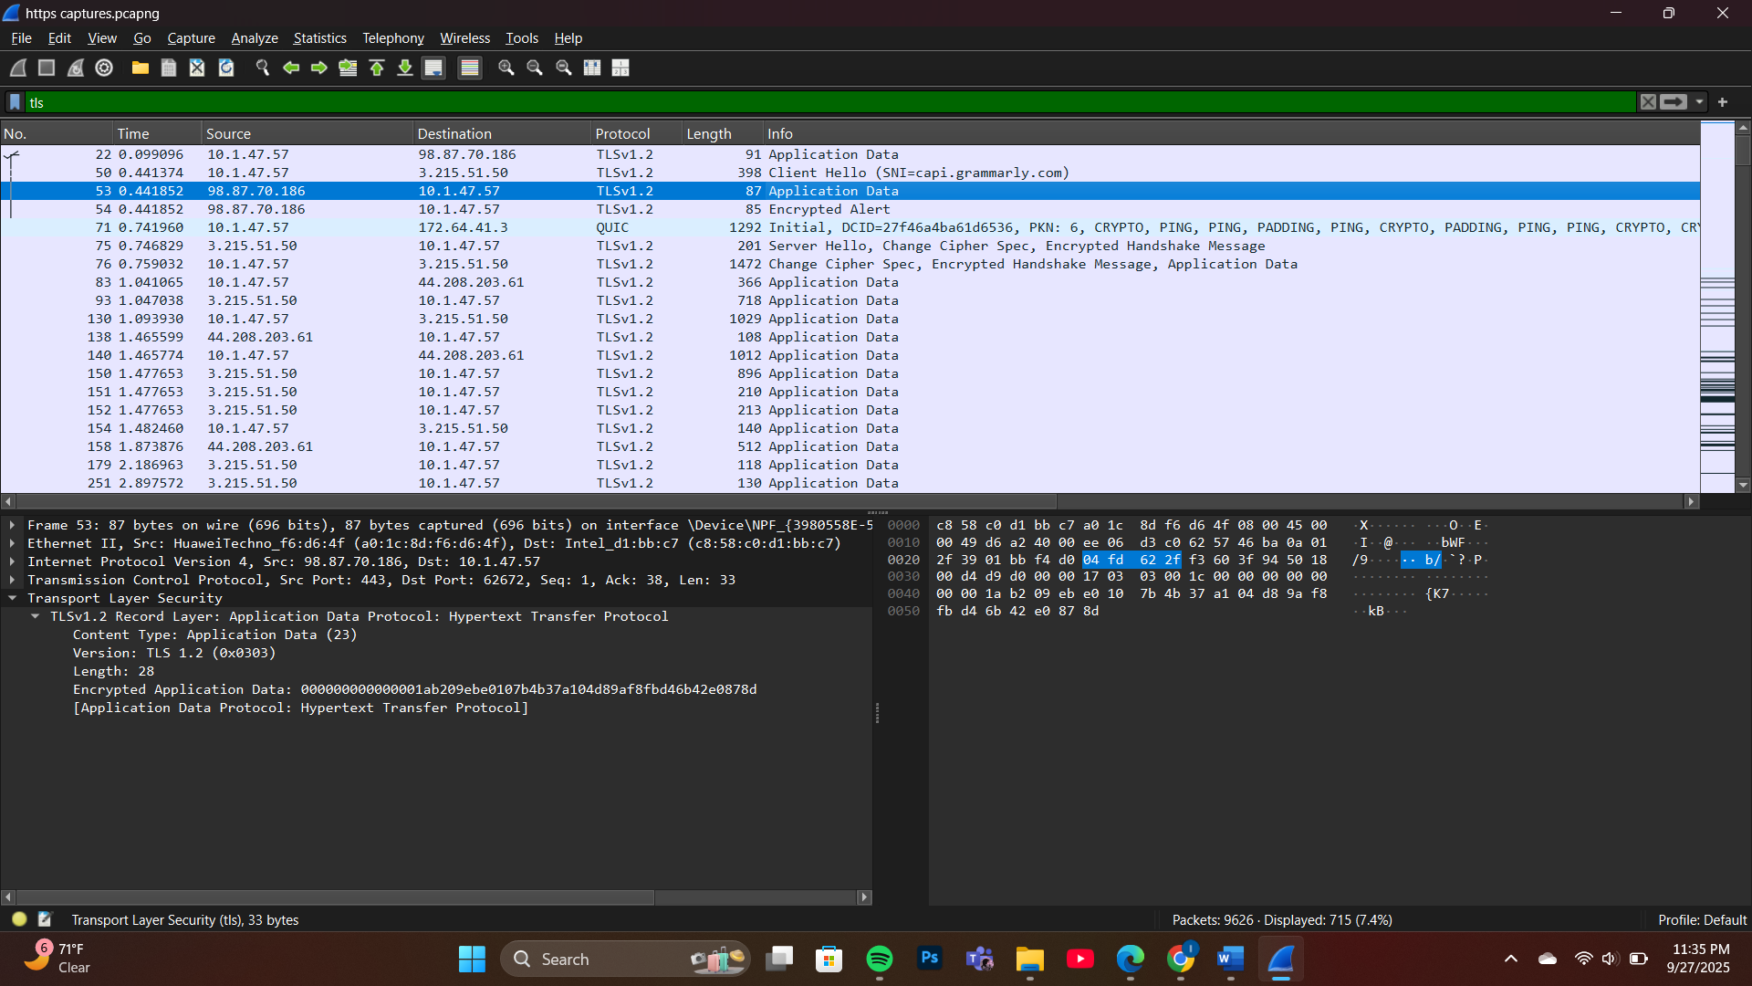

- Question: After TLS handshake, identify if you can see HTTP headers in packets
- Answer: No, because data is encrypted

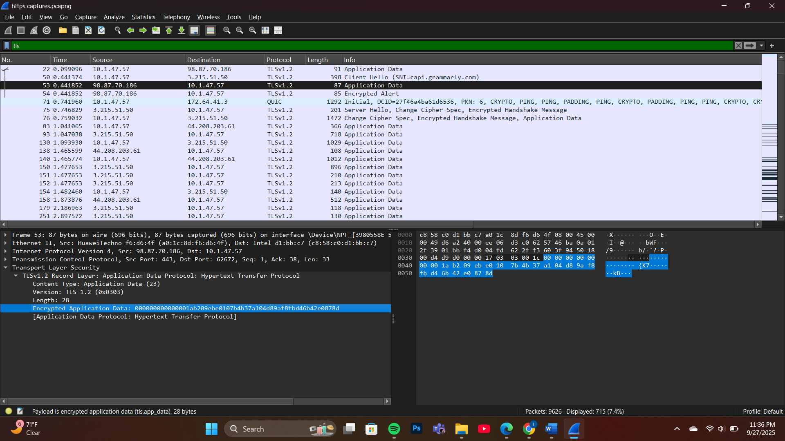

TLS Handshake Completion Analysis:

Method: Examined Application Data packets after TLS handshake completion

Findings:
  - Multiple "Application Data" packets identified (packets 22, 53, 76, 83, etc.)
  - TLS version: TLSv1.2
  - Application data is present after handshake completion

Question: Can you see HTTP headers in the Application Data packets?
Answer: NO, because the data is encrypted

Evidence:
  - Application Data packets show "Encrypted Application Data"
  - No readable HTTP headers visible in packet contents
  - TLS encryption protects all application-layer data
  - Only TLS record headers are visible, actual HTTP content is encrypted

Conclusion: After TLS handshake completion, all HTTP communication is encrypted and cannot be read from packet capture, demonstrating the security provided by TLS protocol.

Use of TLS filter
- tls filter is used in Wireshark to capture and analyze TLS handshake messages (ClientHello, ServerHello, Certificate, etc.).
- It isolates encryption-related packets only, making the handshake easier to study.
Why not https filter
- Wireshark doesn’t have an https filter, because HTTPS is just HTTP over TLS.
- All HTTPS traffic appears as TLS packets — so the correct filter is tls, not https.
Summary
I have applied the TLS filter to clearly observe the handshake and encryption process of HTTPS traffic. It allowed me to see server identity (certificate), chosen cipher suite, and handshake details. After the handshake, all application data is encrypted, proving HTTPS protects the actual HTTP content.

